**Screenshot – Assignment 2 by Venneti Kalyana Chakravarthy**

**Question 1:** Write a program which accepts a sequence of comma-separated numbers from console and generate a list

**Solution:**

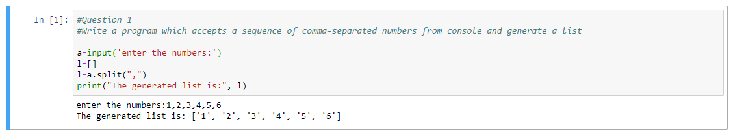

**Question 2:** Create the below pattern using nested for loop in Python



**Solution:**

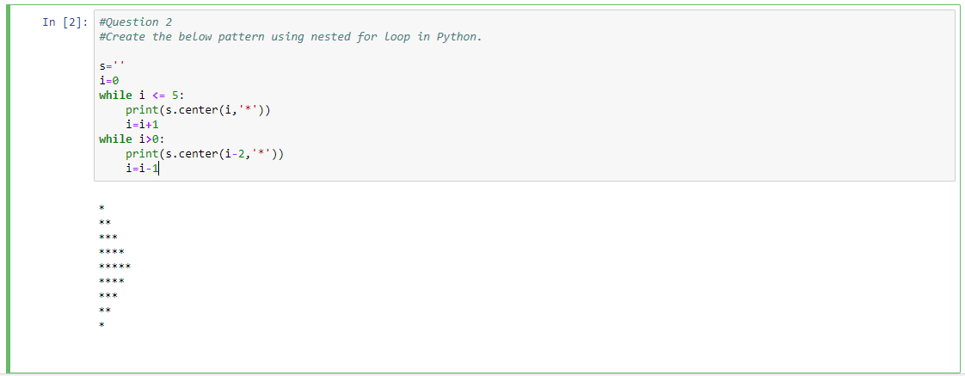

**Question 3:** Write a Python program to reverse a word after accepting the input from the user.

Sample Output:

Input word: AcadGild

Output: dilGdacA

**Solution:**

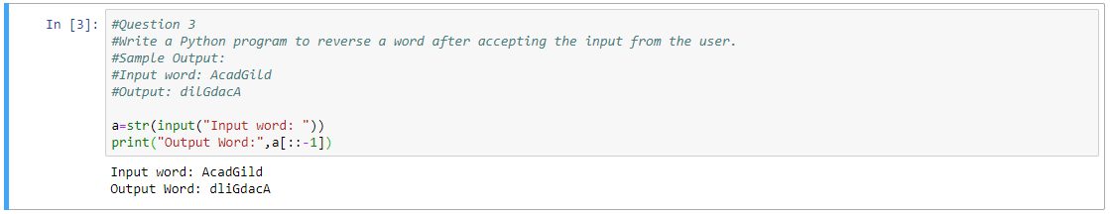

**Question 4:** Write a Python Program to print the given string in the format specified in the sample **output.**

WE, THE PEOPLE OF INDIA, having solemnly resolved to constitute India into a SOVEREIGN,  
SOCIALIST, SECULAR, DEMOCRATIC REPUBLIC and to secure to all its citizens

**Sample Output:**

WE, THE PEOPLE OF INDIA,

having solemnly resolved to constitute India into a SOVEREIGN, !

SOCIALIST, SECULAR, DEMOCRATIC REPUBLIC

and to secure to all its citizens

**Solution:**

